**Use Case Diagram for Acmeplex**

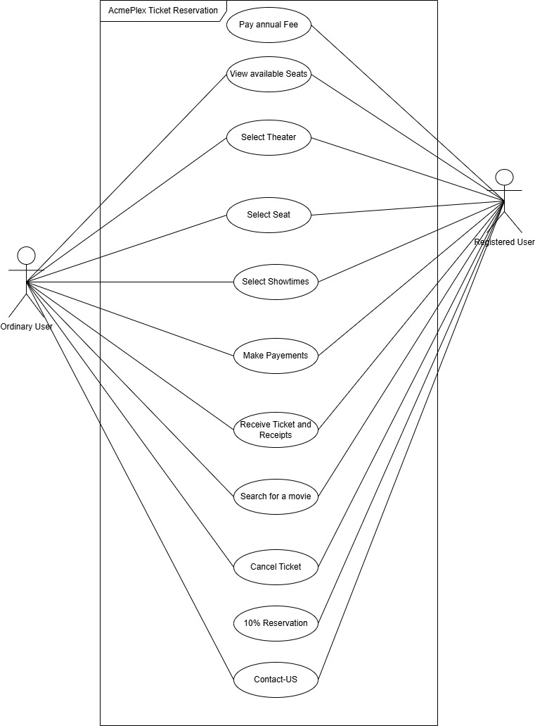

**AcmePlex Ticket Reservation Use Cases Scenarios**

**Ordinary User Scenarios**

**Search for a Movie**

For the "Search for a Movie" use case, the AcmePlex application displays a search bar where the user can enter the movie title. Once the user submits the search, the system retrieves a list of matching movies, including their name and available showtimes, and displays them for the user to select from.

**Select Theater and Showtimes**

For the "Select Theater and Showtimes" use case, the AcmePlex application allows the user to select a movie from the search results. The system then displays a list of available theaters along with the showtimes for the selected movie. The user chooses their preferred theater and showtime, and the system confirms the selection and highlights the choice for further actions.

**View Available Seats**

For the "View Available Seats" use case, the AcmePlex application displays a graphical seat layout for the selected theater and showtime. The seat layout includes markers for available and reserved seats, represented by distinct colors. The user can visually browse the layout to check seat availability before proceeding.

**Select Seat**

For the "Select Seat" use case, the AcmePlex application allows the user to click on one or more available seats from the graphical seat layout. The system highlights the selected seats and displays the total price for the selection. It then prompts the user to confirm their seat choice before moving to the payment step.

**Make Payments**

For the "Make Payments" use case, the AcmePlex application displays a payment form where the user is prompted to enter their credit card number, expiry date, and CVV. After the user submits the payment information, the system processes the transaction securely. Upon success, the system displays a confirmation message and provides the transaction details for the user.

**Receive Ticket and Receipts**

For the "Receive Ticket and Receipts" use case, the AcmePlex application generates a digital ticket and receipt after a successful payment. The user can either download the ticket and receipt directly from the application or request them to be sent via email. The system ensures the ticket and receipt are available for future reference.

**Cancel Ticket**

For the "Cancel Ticket" use case, the AcmePlex application allows the user to enter a previously booked ticket for cancellation. Upon confirmation, the system deducts a 15% administrative fee and processes the refund for the remaining amount. The user is notified of the cancellation and refund status via a confirmation message.

**Registered User Scenarios**

**Pay Annual Fee**

For the "Pay Annual Fee" use case, the AcmePlex application displays the "Pay Annual Fee" section to the user, with the default annual fee pre-filled. The user is prompted to enter their payment details, including the credit card number, expiry date, and CVV. Once the user submits the information, the system securely processes the payment, confirms the transaction, updates the user's registered status, and generates a receipt that is available for download or sent via email.

**10% Reservation**

For the "10% Reservation" use case, the AcmePlex application allows registered users to reserve seats from a 10% reserved allocation before public bookings open. The system checks availability within the reserved quota and confirms the reservation for the user. If the reserved quota is full, the system notifies the user and provides alternate suggestions, such as other seats or showtimes.

**All Ordinary User Actions**

For the "All Ordinary User Actions" use case, registered users can perform all actions available to ordinary users, such as searching for a movie, selecting seats, and making payments. However, they are exempt from the 15% administrative fee when canceling tickets, giving them an added benefit.

**Common Scenario for both users:-**

**Contact Us**

For the "Contact Us" use case, the AcmePlex application provides a contact form where users can enter or their queries or concerns. The user is prompted to fill in details such as their name, email address, and message. Once the user submits the form, the system sends the message to the customer support team and displays a confirmation message, indicating that the support team will respond promptly. Additionally, the user receives an acknowledgment email with a reference ID for tracking their inquiry.

**Good Candidates Identified**

**Candidate Objects:**

The following key entities were identified as good candidates for objects:

* Ordinary User, Registered User
* Search Bar, Graphical Seat Layout
* Movie, Showtime, Theater, Seats
* Payment Form, Credit Card Details (e.g., Card Number, Expiry Date, CVV)
* Ticket, Receipt
* Contact Form, Name, Email Address, Message
* Administrative Fee, Reference ID

**Candidate Operations:**

The following actions were identified as good candidates for operations:

* search, select, browse
* highlight, confirm
* enter, process, retrieve, notify
* display, generate, store, download
* cancel, suggest, send

**Notation Used**

Single underline (e.g., Object Name): Represents candidate objects.

Double underline (e.g., Operation Name): Represents candidate operations.